

VistAWeb

Version 8.0

WEBV*1*13

User Manual

November 2008

Department of Veterans Affairs
Office of Information & Technology
Health Provider Systems, Current Systems

Revision History
Date | Patch | Page(s) | Change(s) | Project Manager | Technical Writer
Oct 2008 | WEBV*1*13  VistAWeb 8.0 | Throughout | Updated screen captures and various edits, per developer and EPS reviews. | Madsen | JoAnn Green
June 2008 | WEBV*1*13  VistAWeb 8.0 | p.5 | Added section on what’s new in Version 8.0 | Madsen | JoAnn Green
June 2008 | WEBV*1*14  VistAWeb 7.5 | p.5 | Added section on what’s new in Version 7.5 | Madsen | JoAnn Green
May 2008 | WEBV*1*14  VistAWeb 7.5 | p 36,17 | Added reference to Chem and Hematology; added figure 29b | Madsen | JoAnn Green
October 2007 | WEBV*1*11  VistAWeb 7.0 | p.5 | Added section “What’s New in Version 7.0?” Incorporated what was new in version 6.0 interspersed throughout the manual | Madsen
June 2007 | WEBV*1*9  VistAWeb 6.5 | NA | Changes were made to the way VistAWeb handles server connections. | Madsen | NA
December 2006 | WEBV*1*8  VistAWeb 6.0 | n/a  p.1  p.19  p.22  p.26  p31  p.35  p.37  p.39 | Minor text edits throughout.  Tightened up text in Introduction section to better reflect functionality and access to VistAWeb.  Consolidated “Accessibility” section and “Launching” sections under heading, “Accessing VistAWeb.”  Added note about requirement for updating Verify codes by standalone users.  Revised special user access contact.  Revised text and added Discharge Summary figure to properly account for date range choices, including the changed date range for Med Admin BCMA reports.  Added two new figures to section on Vitals Detail to help illustrate standard vs. nonstandard vitals data.  Added timeout screen shots and description.  Added acronyms list to end of document. | Madsen | Kelsey

Table of Contents
Revision History ii
Table of Contents iv
Introduction to VistAWeb 1
Brief Overview of the HDR 1
Known Constraints 3
Figure 1: Setting Internet Explorer to Allow Pop-ups 4
What’s New with VistAWeb Release 8.0? 5
VistAWeb Version 8.0 Features/Enhancements 5
Standard Printing 5
FHIE to BHIE name change 6
Complex Documents 6
View Details windows for Allergies and Outpatient Pharmacy 6
VistAWeb Version 7.5 Features/Enhancements 7
VistAWeb Version 7.0 Features/Enhancements 7
Ad Hoc Health Summaries 7
Figure 2: Ad Hoc Health Summary Report Selection 8
Figure 3: Additional Ad Hoc Components 8
Improved Navigation for Vitals 8
Figure 4: Grid View 9
Figure 5: Graph View 9
Enhanced Sorting of Grids 9
Icons and Hover Text 10
Table 1: Icons and Hover Text for Progress Notes and Consults and Procedures 10
Figure 6: Consults and Procedures Report, Icon Column, and Hover Text 11
Veterans Tracking Application 11
Figure 7: VTA Link 12
Department of Defense Documents 12
Figure 8: Progress Notes for Pre- and Post-Deployment Health Assessments 13
Consults 13
Anatomic Path(ology) Reports 13
Figure 9: Anatomic Path Reports 13
View Detail Display 13
Figure 10: Example Medication Detail 14
Broker Security Enhancement (BSE) 18
Grid View of Surgical Pathology and Cytology Reports 18
Accessing VistAWeb 19
VistAWeb under the CPRS Tools Menu 19
Figure 11: VistAWeb Access from the CPRS Tools Menu 20
Figure 12: Initial Launch Using CPRS Access and Verify Codes 21
Access to VistAWeb from CPRS VistaWeb Button 22
Figure 13: VistAWeb from the VistaWeb Button 22
Figure 14: New Remote Data Tool message on Options screen 23
Patient Context in CPRS-Spawned VistAWeb 23
Figure 15: VistAWeb Maintains Context with the CPRS Patient 24
Figure 16: Two CPRS Sessions: One in Context, One Not in Context 25
VistAWeb Directly from IE (“Standalone” VistAWeb) 25
Figure 17: VistAWeb Home Page 26
Figure 18: VistAWeb – VistA Site-Login Screen 27
Patient Selection 27
Figure 19: Using the Patient Selection Screen to “Find” a Patient 28
Special Users 28
Figure 20: Special User Multiple Site and Patient Selection 29
Requesting Special User Access 29
Sensitive Patient Warning 30
Figure 21: Restricted Record Warning 30
Refresh Patient Data 30
Figure 22: Refresh Patient Data Button 30
Category 1 Patient Record Flags 31
Figure 23: Example Category I Patient Record Flag in Standalone VistAWeb 31
Figure 24: Example Category I Patient Record Flag on the Sites & Notices Screen 31
Using VistAWeb 32
Automatic Retrieval of Data from Multiple Sites 32
Figure 25: Please Wait…Message 32
Figure 26: Patient Data Available at Multiple Sites 33
Expanded List of All Reports 33
Example 1: Expanded List of VistAWeb Reports 34
Report Examples 35
Text Reports 35
Figure 27: Patient Inquiry Text Report 35
Text Report with Date Range Option 35
Figure 28: Date Range Entry and Radio Button Selection 36
Figure 29: Progress Notes Report with Date Range, Number, and Query 36
Figure 29b: Progress Notes Report with Chem & Hematology 37
Predefined Filtering and Date Range 37
Figure 30: Date Range Selection Criteria for All Outpatient Pharmacy Report 38
Figure 31: Date Range for Lab and Other Large Volume Reports 39
Data Grid Style of Report 39
Data Grid with View Detail 39
Figure 33: Progress Notes 40
Figure 34: View Details of Progress Note 41
Figure35: Vital Sign Report Presented as Table 41
Figure 36: View Details of HT Standardized Vitals 43
Figure 36: View Details of Non-HT Standardized Vitals 43
Figure 37: View Details of Non-Standardized Vitals 44
Data Grid with Copy to Clipboard Option 44
Figure 38: Copy to Clipboard 45
Figure 39: Medications from VistAWeb Pasted into CPRS Progress Note 46
Figure 40: Non-VA Medications 46
VistAWeb Timeout 47
Figure 41: VistAWeb Timeout Dialog Box 47
Figure 42: Internet Explorer Close Dialog 47
Figure 43: Empty Session Message – Rerun VistAWeb 48
Figure 44: Empty Session Message – Use a Different Browser Window 48
Acronyms and Abbreviations 49

Introduction to VistAWeb
Veterans Health Information Systems and Technology Architecture (VistA) VistAWeb is an intranet web application used to review remote patient information found in VistA and the Health Data Repository (HDR) databases. To a large extent, VistAWeb mirrors the reports behavior of the Computerized Patient Record System (CPRS) and Remote Data View (RDV). However, by permitting a more robust and timely retrieval of remote-site patient data, VistAWeb is also an enhancement to CPRS/RDV.
There are three ways to access VistAWeb. VistAWeb can be made available by adding it to the CPRS Tools Menu, and it can be selected as the default method of retrieving data from the Remote Data Available button in CPRS. These two methods are referred to as CPRS-spawned versions of VistAWeb. They are compliant with the Health Level 7 (HL7) Clinical Context Object Workgroup (CCOW) standards and therefore maintain context with the patient selected in CPRS. As a third option, VistAWeb can be accessed in a standalone mode by entering the uniform resource locator (URL) link (https://vistaweb.med.va.gov/) in the Internet Explorer address bar. These methods of accessing VistAWeb are discussed in more detail in later sections of this manual.
Note: Some links found in this user manual go to sites or pages found on the VA intranet. These sites or pages are not accessible from outside the VA network.
The standalone version of VistAWeb is connected to neither CPRS nor the clinical context management application. Standalone VistAWeb serves an important function for users who have been granted special access to multiple sites, such as for National Programs, Veterans Administration (VA) researchers, and others. VistAWeb was also made available more broadly, though temporarily, to assist clinical staff with the retrieval of patient information from the sites affected by damage caused by hurricane Katrina.
To fully appreciate the data that VistAWeb presents to the user, it is important to know something about the HDR as one of the sources of that data. Please read the following section to familiarize yourself with the purpose of the HDR and some of the terms and acronyms that describe it, as these will be used in subsequent sections of this manual.

Brief Overview of the HDR
The purpose of the HDR project is to establish a clinical data repository. A clinical data repository is a collection of clinical information that resides on one or more independent platforms and is used by clinicians and other personnel to facilitate longitudinal patient-centric care. The data in the HDR will be retrieved from existing VistA files and organized in a format that supports the delivery of care, regardless of the patient's current location or where the patient has been treated in the past. Additionally, the HDR will serve five main purposes:
- Serve as a primary source for the legal health record (LHR)
- Enable the generation of clinical reports based on the entire clinical holdings of Veterans Health Administration (VHA)
- Serve as a platform for a re-engineered CPRS
- Serve as a platform for patient self-access to the medical record
- Support standardization between and among Department of Defense (DoD), Indian Health Services (IHS), and other government and private industry clinical databases through the creation of a standards-based database
To accomplish this complex task of consolidating the clinical patient data from all of the VistA sites and creating a new system of data storage and retrieval, three different, but interrelated database strategies are being employed: HDR-Historical (Hx), HDR-Interim Messaging Solution (IMS), and HDR II. To date, only HDR-Historical and HDR-IMS are storing data.
Data in HDR-Hx is being extracted from VistA sites on a domain-by-domain basis from a specified “date-backward” to the beginning of the clinical records in VistA and stored in a relational database. VistA data from a specified “date-forward” is stored on a domain-by-domain basis in the HDR-IMS database as HL7 messages. Data in HDR-IMS has been standardized by VHA’s Data Standardization team in collaboration with domain stakeholders and subject matter experts. The data in HDR-Hx for these same domains has not been standardized—except for Allergies. A project decision was made to standardize the main VistA allergy file both backward and forward in time because a previously reported allergy, for instance an allergy to Penicillin, would have obvious relevance to present-day patient care. Standardized allergy data is coded and computable and thereby amenable to automated drug-allergy order checking. Currently a total of thirty domains, or major portions of clinical domains, have been targeted for storage in the HDR. It is anticipated that these domains will be standardized to varying degrees.
A read service (and in the future, a write service) called Clinical Data Service (CDS) returns the clinical patient data for the Vitals, Allergies, and Outpatient Pharmacy domains from the HDR databases to the VistAWeb application in response to requests for data by VistAWeb users. If both HDR-Hx and HDR-IMS contain the same record, VistAWeb discards the duplicate, displaying only the HDR-IMS data. Furthermore, there is duplicate data in VistA databases and both HDR databases because all of the data that has been extracted for the Historical database or stored in the IMS database came from or is still being sent to VistA databases. When VistAWeb retrieves site (VistA) records and duplicate records from the HDR, VistAWeb displays the HDR instance of the record.

Known Constraints
There are known constraints in the installation and use of VistAWeb:
- VistAWeb is a CCOW-compliant application. If VistAWeb is launched from CPRS on a computer without the CCOW-compliant Vergence Desktop Components installed, a message will be displayed saying “VistAWeb is CCOW compliant and has been unsuccessful in locating a CCOW vault. Please contact your local IRM for assistance.” VistAWeb will then exit.
Note: Information Resources Management (IRM) staff should refer to the VistAWeb Informational Patch OR*3*230 for guidance on where to find information and who to talk to about installation and configuration of the CCOW Desktop Components. Additional CCOW information can be found at http://vista.med.va.gov/vistaweb/Desktop_Components.htm and http://vista.med.va.gov/CCOW/index.html.
- Access to VistAWeb in a test account should not be made available to general users. Access should be made available in a production account. Accessing VistAWeb in test accounts will require the user to enter the IP address and port number of the test system each time a patient selection is performed. Access to VistAWeb in a test account should be restricted to IRM staff for limited testing purposes only.
Note: Using VistAWeb to look up “test patients” may produce confusing results. Normally, no two sites ever have the same test patients. Using a test patient in a production account may seem to work satisfactorily, but can cause VistAWeb to error out as it attempts to reconcile a test patient at multiple sites.
- VistAWeb uses pop-ups. Field facilities that have chosen to turn off pop-ups on desktops will need to allow them for VistAWeb. In Internet Explorer in the Tools menu pull-down, select Pop-up Blocker>Pop-up Blocker Settings, type the VistAWeb URL in the Address of the Web site to allow: box, and click the Add button (Figure 1).

Figure 1: Setting Internet Explorer to Allow Pop-ups
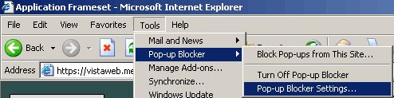
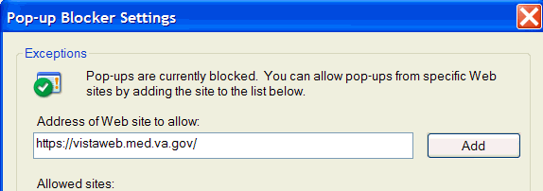
Note: Some links found in this user manual go to sites or pages found on the VA intranet. These sites or pages are not accessible from outside the VA network.

What’s New with VistAWeb Release 8.0?
Several enhancements and fixes have been included in VistAWeb in the 8.0 release. If you are already familiar with VistAWeb, read this section of the manual to find out what’s new in this release. If you are not familiar with VistAWeb, you may want to start with Accessing VistAWeb and then come back to this section to find out what’s new.

VistAWeb Version 8.0 Features/Enhancements
- Resolves PSPO-970 - Remedy ticket # 259376 - Inpatient Medications from a previous VA inpatient stay may not display in Remote Data View (RDV) and VistAWeb "Pharmacy - Medications" view of medications, depending on the current VA patient status. This may result in problems such as the need to continue the meds, knowing about the meds if side effects occur several days later, etc.

- The special user access message has been changed to:
If you need to look up a patient who has not been seen at your VAMC (remote site patient lookup), you must request Special User access to VistAWeb. Ask for special user access by emailing the VHA CO CAPRI access team vhacocapri@va.gov.

- The OOPS message has been changed to:
Oops
An error has occurred. If the problem persists please contact your local IRM/Computer support staff or log a ticket with the VA Service desk (VASD) at 1-888-596-4357. Please provide the process you were performing and the date/time the error occurred."

- A fix has been included in v8 for the problem with multiple threads locking up VistaWeb so that some data may not appear in Notes.

Standard Printing
- The print function has been removed from Internet Explorer (IE) and put in VistAWeb
- A standard VistAWeb header appears on all printed reports. This header, which contains patient-identifying information, appears on the first page of the printed report.

- The footer of printed pages will contain the name of the person who printed the report.

- Line Feeds
    - No line feeds occur between pages.
    - Line feeds will occur between documents.

- Clipboard
    - IE 6: When you do a copy to clipboard, this data is available to other web pages. This poses a patient safety issue, since patient information could be inadvertently pasted into other web pages.
    - IE 7: Users can set up an option to prevent the clipboard data from being available to other web pages.

NOTE: - The printouts may not print all of the columns of a grid report, depending on the formatting or the size of the browser window. A message has been added to the print dialog window for grid reports and for grid report printouts, as follows:
***WARNING: Printed grid reports may not show all columns.. Check printouts carefully.***

FHIE to BHIE name change
- The note on the tree view that reads:
† - Pages with FHIE data (Dept. of Defense)
- Has been changed to:
† - Pages with BHIE data (Dept. of Defense)

Complex Documents
- VistAWeb will display Department of Defense data for Vitals.
- The Problem List Report will display Department of Defense data.

View Details windows for Allergies and Outpatient Pharmacy
- For Allergies and Outpatient Pharmacy, detailed display windows for HDR records currently show up as blank. For such records, a call will be made to VistA to get the details. After this fix, the view details windows for Allergies and Outpatient Pharmacy will no longer be blank.

VistAWeb Version 7.5 Features/Enhancements
- Resolved PSI-08-057 (also known as Remedy #245921) “'All Results' in the Chemistry and Hematology report not returning all results.” Users can now specify a limit (per site) on the number of reports returned, with the default being 50.
- Fixed the formatting of the Surgery Report columns “DictationTime” and “Transcription Time.”
- Added the “Reason for Study” column in the Radiology Report (this will be populated when CPRS v27 rolls out.)
- Past Clinical Visits report displaying "RSA ERROR" when "All Results" is selected (Remedy 241666)
- Resolved PSI-08-078 (also known as Remedy #249810) FHIE/BHIE data was missing on the “All Outpatient Pharmacy” report (meds with an expiration date greater than the current date)

VistAWeb Version 7.0 Features/Enhancements
Ad Hoc Health Summaries
The capability of producing temporary ad hoc health summaries has been added to VistAWeb. This is similar to the ad hoc Report functionality in CPRS. After you select a patient and Ad Hoc Report under the Health Summaries menu, you can select from a list of Ad Hoc Reports and a list of File Selections to be included in your report. Then, if applicable to your selections, you can specify Header Name, Occurrence Limit, Time Limit, Display Hospital Location, Display Provider Narrative, and ICD Text Display, or you can select site-defined defaults. When sub-items are available, another “slush bucket” pops up for you to enter selections. Click the Run Report button to generate your ad hoc report (Figure 2). In the case of this example, an attempt was made to add an additional subcomponent, and the user was informed in small print above the Select Ad Hoc Reports window “Limit exceeded. Cannot add more sub-components.” Figure 3 shows some of the additional selections that are available when “Outpatient Diagnosis” is selected as the “Header Name.” For more information on ad hoc health summary components, please refer to the CPRS Technical Manual.
Figure 2: Ad Hoc Health Summary Report Selection
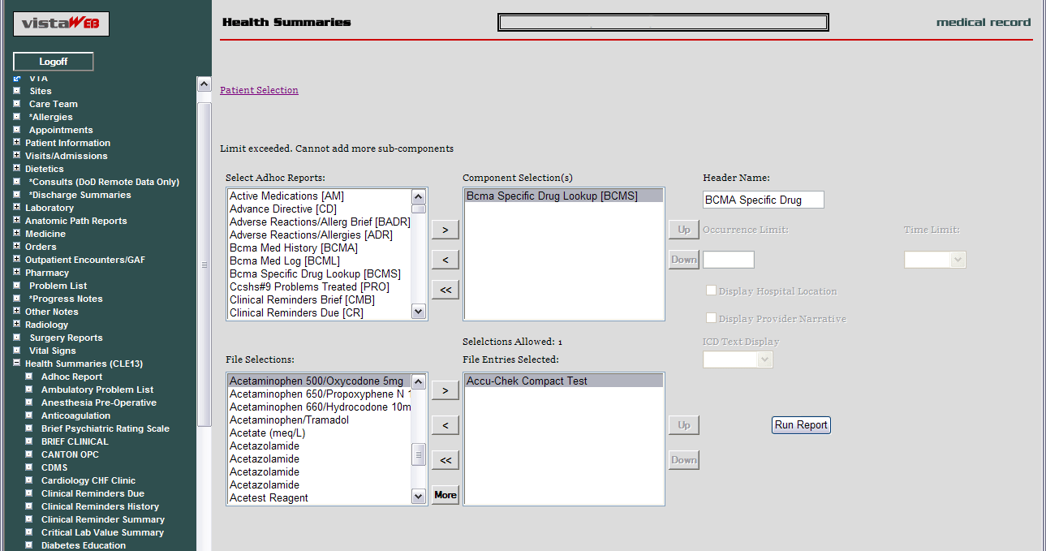
Figure 3: Additional Ad Hoc Components
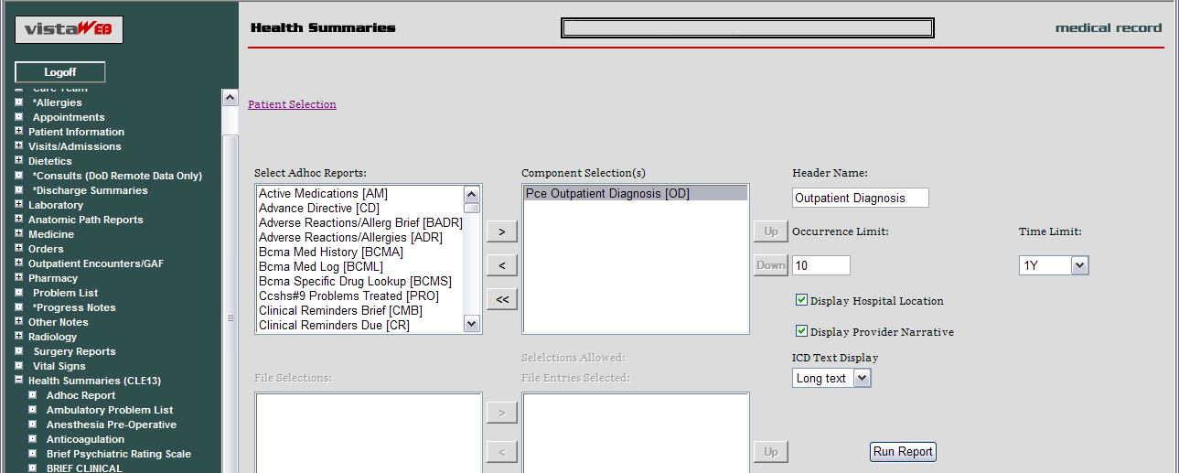
Improved Navigation for Vitals
The vitals report now allows you to switch between grid and graph views, which permits graphing of multiple vital signs without having to return to the initial Vitals date selection screen. Figure 4 shows the Vitals Grid view.

Figure 4: Grid View
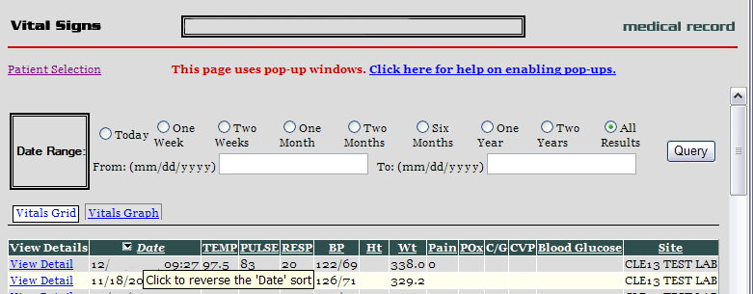
When you click on the Vitals Graph button, the screen displays selection radio buttons for the Vital Type, the Chart Type, and Dimension (Figure 5). In addition, to the Grid and Graph buttons, the vitals have been ordered to coincide with the order found on the View Detail report, and the table has been restructured so it better fits the screen area.

Figure 5: Graph View
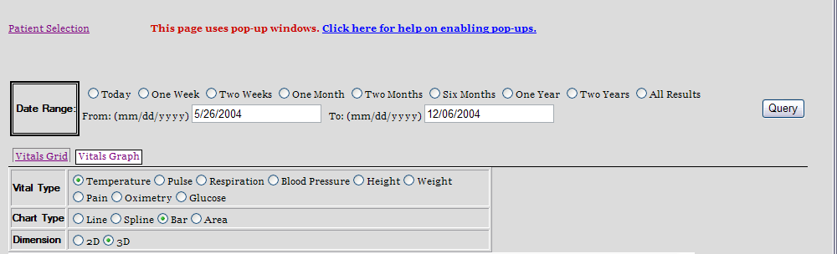
Enhanced Sorting of Grids
Look back at Figure 4 and note that there is a small triangle next to Date in the Date column with hover text that says, “Click to reverse the ‘Date’ sort.” You can click on the triangle to reverse the date-order of the table. Columns that can be sorted are underlined. When you click on any of the other underlined column headings, they will re-sort and the reverse sort triangle will appear next the column heading you just sorted. The capability to reverse the sort helps provide easier access to data; for example, you can now reverse the sort on the Last Fill Date in the Outpatient Pharmacy grid to get the most recent dates at the top of the list instead of at the bottom.
Icons and Hover Text
An Icon column and hover text have been added to the Progress Notes report and the newly added Consults and Procedures report. Table 1 shows the icons and their associated hover text. Figure 6 shows the Consults and Procedures report, the Icon column, and the hover text for a Procedure note.
Table 1: Icons and Hover Text for Progress Notes and Consults and Procedures
View attached image in CPRS
Progress note
Progress note addendum
Progress note with addendum
Interdisciplinary child note
Interdisciplinary note addendum
Interdisciplinary child note with addendum
Interdisciplinary parent note
Interdisciplinary parent note with addendum
Consult request
Procedure request
Interfacility consult request
Interfacility procedure request
Figure 6: Consults and Procedures Report, Icon Column, and Hover Text
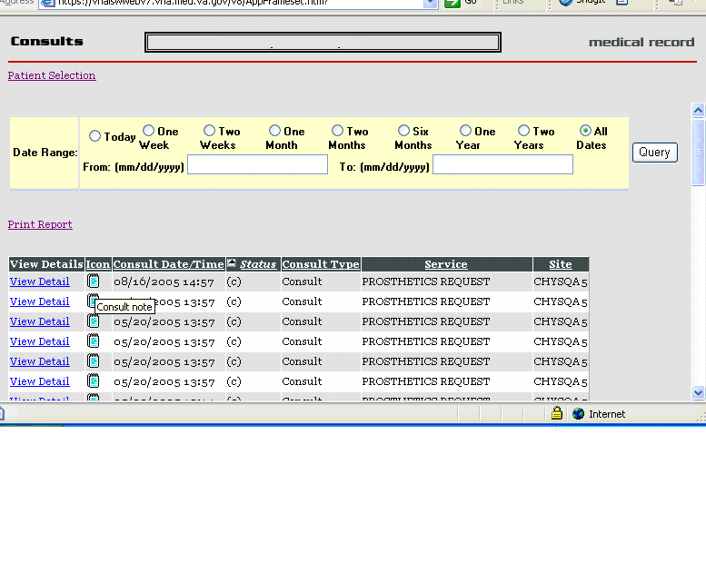
Veterans Tracking Application
A link to the Veteran Tracking Application (VTA) has been added at the top of the VistAWeb reports menu tree (see Figure 7). VTA is a modified version of the DoD Joint Patient Tracking Application (JPTA). After the link is clicked, the VTA SharePoint website is displayed if the user has already received access permission to the site. If the user has not requested and received access permission, a screen is presented where the user can make that request.
Current functionality allows the display of Patient Treatment History notes entered directly into VTA by VA/DoD Liaisons and Case Managers, as well as a link to display clinical data from the DoD Composite Health Care System (CHCS) and a link to Theater data.
Note: In both standalone and spawned VistAWeb, patient context is not maintained when users make patient selection changes. CCOW capability is not yet available.
Note: There currently is no link to VTA provided through CPRS.
Figure 7: VTA Link
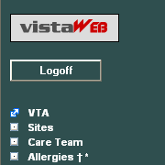
Department of Defense Documents
Additional Department of Defense (DoD) documents have been added to VistAWeb. Note that the symbol indicating potential DoD data now follows the menu name, rather than preceding it. This enhancement was done to improve accessibility for assistive technologies. The new reports are:
- Expanded ADT†
- Consults and Procedures†
- Consults (DoD Remote Data Only) †
- Discharge Summaries†
- Outpatient Encounters†
- Problem List †
- Vitals†
Several other reports were previously available as part of the growing list of DoD reports. For example, the Pre-deployment and Post-deployment Health Assessments Progress Notes report was made available in a previous release of VistAWeb (Figure 8).

Figure 8: Progress Notes for Pre- and Post-Deployment Health Assessments
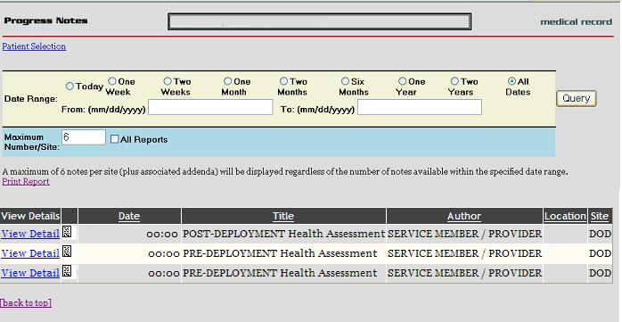
Consults
Consults report has been added to the VistAWeb menu. Clicking on the Consults menu item will bring up the Consults grid. The grid will display some of the Consult information, and a View Detail link will present the detailed Consult information, as shown in the list in the next section of the manual under Orders – Current Orders, Consults.
Anatomic Path(ology) Reports
Anatomic Pathology Reports have been added to the menu of reports. The menu item expands to show Surgical Pathology and Cytopathology reports (Figure 9).
Figure 9: Anatomic Path Reports
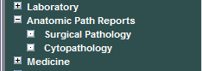
View Detail Display
The details displayed in the View Detail reports have been enhanced for Allergies, Orders – Current Orders, Surgery, and Outpatient Pharmacy. An example of the Current Orders Medications Detail is shown in Figure 10. Lists delineating the View Detail enhancements follow the Medication Detail example.
Figure 10: Example Medication Detail
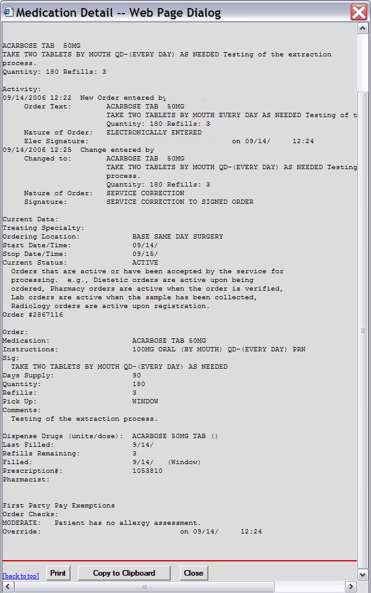
- Allergies
The following fields are displayed if data is available in the View Detail report for drug allergies:
- Causative agent
- Nature of reaction
- Signs/Symptoms
- Drug classes
- Originator
- Originated
- Verified
- Observed/Historical
The following fields are displayed if data is available in the View Detail report for food allergies:
- Causative agent
- Nature of reaction
- Signs/Symptoms
- Originator
- Originated
- Verified
- Observed/Historical
- Orders - Current Orders
The following fields are displayed if data is available in the View Detail report for Current Orders:
- Dietetics Order
- Order Text:
- Nature of Order:
- Ordered by:
- Signature:
- Current Data:
- Current Primary Provider:
- Current Attending Physician:
- Treating Specialty:
- Ordering Location:
- Start Date/Time:
- Stop Date/Time:
- Current Status:
- Order:
- Diet:
- Effective Date/Time:
- Delivery:
- Lab Order
- Order Text:
- Nature of Order:
- Ordered by:
- Signature:
- Current Data:
- Current Primary Provider:
- Current Attending Physician:
- Treating Specialty:
- Ordering Location:
- Start Date/Time:
- Stop Date/Time:
- Current Status:
- Order:
- Lab Test:
- Collected By:
- Collection Sample:
- Specimen:
- Collection Date/Time:
- Urgency:
- How often:
- Consults
- Order Text:
- Nature of Order:
- Ordered by:
- Signature:
- Current Data:
- Current Primary Provider:
- Current Attending Physician:
- Treating Specialty:
- Ordering Location:
- Start Date/Time:
- Stop Date/Time:
- Current Status:
- Order:
- Consult to Service/Specialty:
- Reason for Request:
- Indication for anticoagulation:
- Duration of therapy:
- Desired intensity (INR):
- Dosage patient started on:
- Dosage patient discharged on:
- Contact person once treatment completed:
- Confirm patient phone number & address
- For cardioversion
- Cardiology follow-up scheduled
- Where patient should be followed
- Category:
- Urgency:
- Place of consultation:
- Medication
- Stop Date/Time:
- Current Status:
- Order:
- Medication:
- Dispense Drug:
- Instructions:
- Text:
- Days Supply:
- Quantity:
- Refills:
- Pick Up:
- Priority:
- Comments:
- Order Checks:
- Medication History for:
- Run Date:
- Medication Search List:
- Patient: SSN: DOB:
- Sex: Ht/Wt: Ward:
- Dx: Last Mvmt: Type:
- ADRs:
- Allergies:
- Location:
- Administrative Date:
- By:
- Injection Site:
- Units:
- Units of:
- Medication & Dosage:
- Given:
- Administration:
- Radiology (Imaging)
- Activity:
- Order Text:
- Nature of Order:
- Elec Signature:
- Current Data:
- Current Primary Provider:
- Current Attending Physician:
- Treating Specialty:
- Ordering Location:
- Start Date/Time:
- Stop Date/Time:
- Current Status:
- Order:
- Procedure:
- History and Reason for Exam:
- Category:
- Ordering Location:
- Date Desired:
- Mode of Transport:
- Is patient on isolation procedures?:
- Urgency:
- Submit request to:
- Surgery
The following fields are displayed if data is available in the View Detail report for Surgery:
- Surgical Specialty
- Status
- Lab Work
- Dictation Time
- Transcription Time
- In addition, the Surgery report grid headings now match the CPRS surgery table headings. Operative Procedure, Pre-op Diags, and Post-op Diags headings have been added.
- Outpatient Pharmacy
- A View Detail link was added to the All Outpatient pharmacy grid. The detail is similar to the Medication Detail shown in Figure 10.
Broker Security Enhancement (BSE)
The Broker Security Enhancement (BSE) has been added to VistAWeb. BSE provides for improved security in site authentication. It is transparent to the user. The VistAWeb Technical Manual provides additional information about BSE.
Grid View of Surgical Pathology and Cytology Reports
A grid view of surgical pathology reports, with View Detail providing the full text of the report is provided from the menu tree under the Laboratory – Surgical Pathology report selection. However, the surgical pathologist’s name no longer appears as a column in the grid. This is the result of a change to the remote procedure call (RPC) on the VistA side. The Laboratory – Cytology report likewise presents a summary in a grid, with View Detail for the full-text report, but the cytotechnologist or pathologist name no longer appears as a column in the grid. All of the Lab Summary reports and all of the Anatomic Pathology reports only display full-text reports. They are not supplied in a grid in summary form.

Accessing VistAWeb
There are three methods of accessing VistAWeb.
- Through CPRS under the Tools menu
- Through the VistaWeb button in CPRS
- Directly from Microsoft’s Internet Explorer (IE)
The first two are referred to as CPRS-spawned versions, which maintain context between the patient selected in CPRS and VistAWeb patient, i.e., they are the same patient. The third method is referred to as standalone VistAWeb. It does not maintain context with CPRS.

VistAWeb under the CPRS Tools Menu
To access VistAWeb, you must first log into CPRS using your access/verify codes, select a patient, and select VistAWeb from the Tools menu (Figure 11). VistAWeb will maintain context with the selected patient and retrieve data for that patient from all sites where the patient has records. When you select a different patient from the CPRS File menu, VistAWeb will maintain context with the new selection. This is described in Patient Context in CPRS-Spawned VistAWeb.

Figure 11: VistAWeb Access from the CPRS Tools Menu
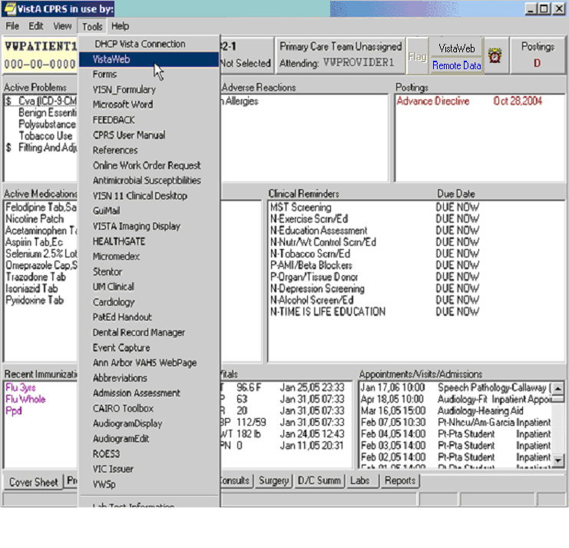
The first time you launch VistAWeb from CPRS, a login (using the same access and verify codes as for CPRS) is required (Figure 12). Subsequent uses of VistAWeb do not require a second login.

Figure 12: Initial Launch Using CPRS Access and Verify Codes
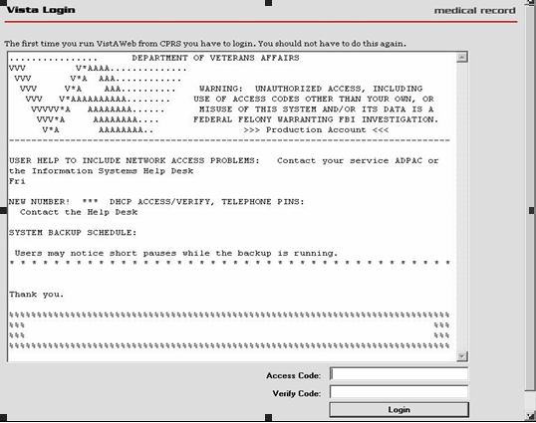

Access to VistAWeb from CPRS VistaWeb Button
A VistAWeb button is now available next to the Remote Data Available button (Figure 2), and CPRS will launch VistAWeb for you. Additionally, when VistAWeb is launched by CPRS, patient context is maintained. This means that VistAWeb will change patients whenever you do a patient selection in CPRS.

Figure 13: VistAWeb from the VistaWeb Button
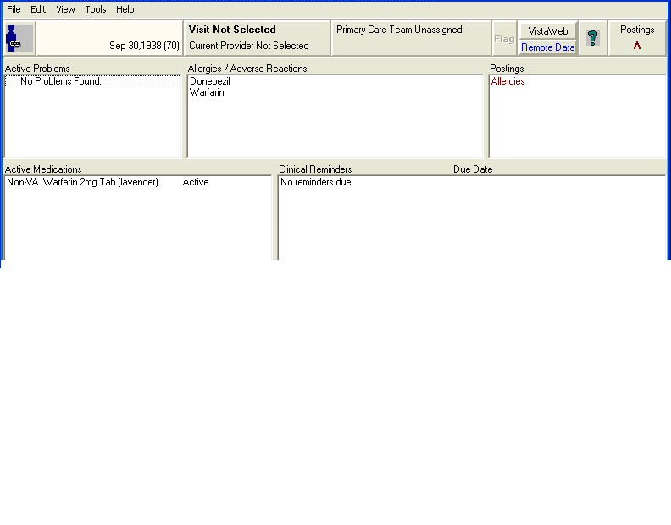

Figure 14: New Remote Data Tool message on Options screen
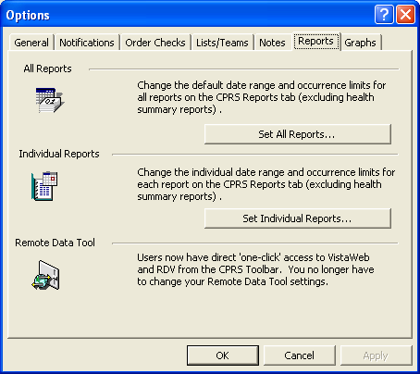

Patient Context in CPRS-Spawned VistAWeb
VistAWeb is a CCOW compliant application and, therefore, maintains context with the patient who was selected in CPRS. When you spawn VistAWeb from CPRS, VistAWeb presents you with a screen that confirms the patient identity, the sites where there is patient data, and gives you the option to proceed or cancel (Figure 15). If you select Proceed, VistAWeb displays the Sites & Notices screen for the new patient along with a menu of reports that are available in VistAWeb. If you select Cancel, VistAWeb forces you to close the session. When using VistAWeb through the CPRS Tools menu, you won’t be able to select a new patient from within the VistAWeb application; however, you can return to CPRS to select a new patient and the VistAWeb connection process will begin again.

Figure 15: VistAWeb Maintains Context with the CPRS Patient
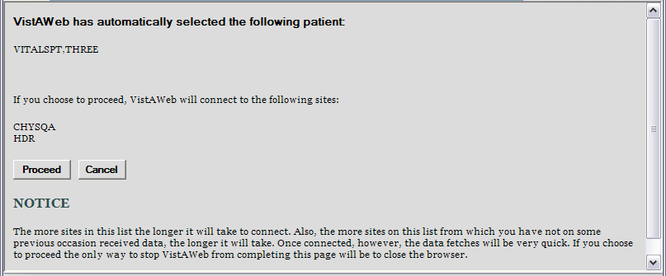
To avoid potential patient safety problems, VistAWeb will not open from a CPRS session that is not in context. This can occur when multiple CPRS sessions are open on the desktop. In the following example (Figure 16), two CPRS sessions are open. One session is in context, as indicated by the icon with a blue person and a connected chain link. The other CPRS session is not participating in patient context, as indicated by the icon with red and blue people and a broken chain. The VistAWeb warning message is the result of attempting to launch VistAWeb from the CPRS session that is not in context. VistAWeb forces the user to exit the attempted connection.

Figure 16: Two CPRS Sessions: One in Context, One Not in Context
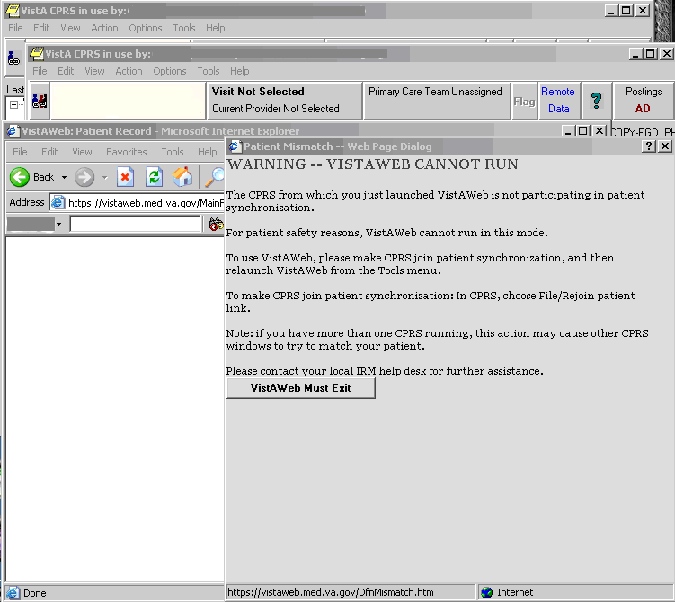

VistAWeb Directly from IE (“Standalone” VistAWeb)
VistAWeb can also be accessed directly from IE by entering https://vistaweb.med.va.gov/ in the IE address bar. Users must select their local site for login, then log in using their CPRS/VistA access and verify code pair.
Note: Some links found in this user manual go to sites or pages found on the VA intranet. These sites or pages are not accessible from outside the VA network.
Once you have made your login site selection, you may want to save the URL in the IE “Favorites” menu for future ease of access.
Note: Users who regularly only use the standalone version of VistAWeb will be required to update their verify codes periodically, just as they would if logging into CPRS. When this happens, the login screen will display the message, “User must enter a new Verify code at this time.”
By default, users will be able to look up only those patients who are in their local VistA site. Data for those patients will be retrieved from all other sites the patients have visited. Some users (researchers or referral coordinators, for example) may need to look up patients who are not in the local VistA. VistAWeb requires that these users be granted Special User access. Special Users and Requesting Special User Access are discussed in more detail later in this manual
Note: An exception to the VistA/CPRS account requirement is made for properly credentialed Special Users, who do not have clinical VistA accounts. For those users, access can be obtained by logging in through the “100. Central Office Claims System,” as shown at the bottom of the sites menu in Figure 17.

Figure 17: VistAWeb Home Page
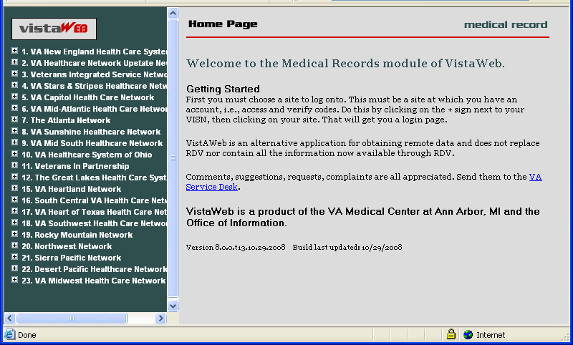
To log into VistAWeb, select the site where you have an account from the list of sites on the left side of the page. The VistA login page for that site will appear (Figure 18). You should enter your access/verify codes the same way you would enter them in CPRS.

Figure 18: VistAWeb – VistA Site-Login Screen
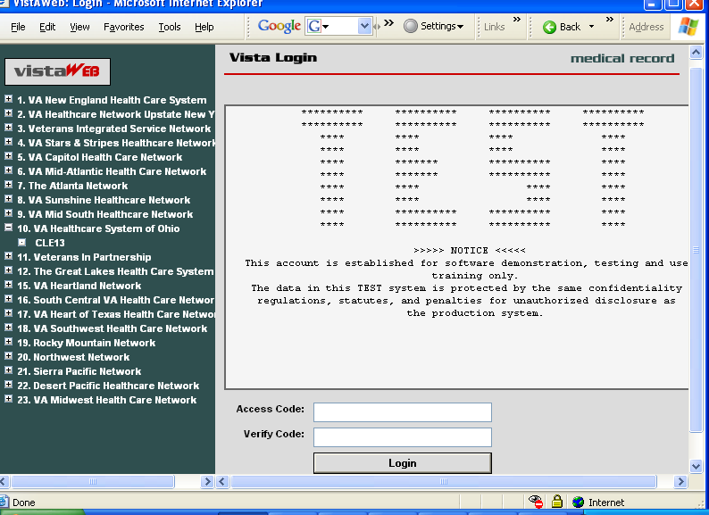
After you log into VistAWeb, the Patient Selection screen appears. If you have Special User access, a list of sites for patient selection will be present on the left side of the screen. Special Users may select a site other than their login site for patient selection. All other users will be limited to patient selection from their login site only. In either case, data for the selected patient will be automatically retrieved from all sites where that patient has data.

Patient Selection
In standalone VistAWeb, patient selection can be performed in much the same way as in CPRS. You can enter the patient’s name, part of the patient’s last name, social security number, or the five-digit identifier (first letter of patient’s last name plus the last four digits of the patient’s social security number). After entering one of these identifiers, click your mouse button on the FIND button or press the Enter key on the keyboard. A list of potential matching patients appears in the box below (Figure 19). If there are more names available than shown in the scroll box, click the “More names…” button to see them. Once you have identified the desired patient, click your mouse button on the patient name, and click the mouse again on the OK button or press the Enter key on the keyboard.

Figure 19: Using the Patient Selection Screen to “Find” a Patient
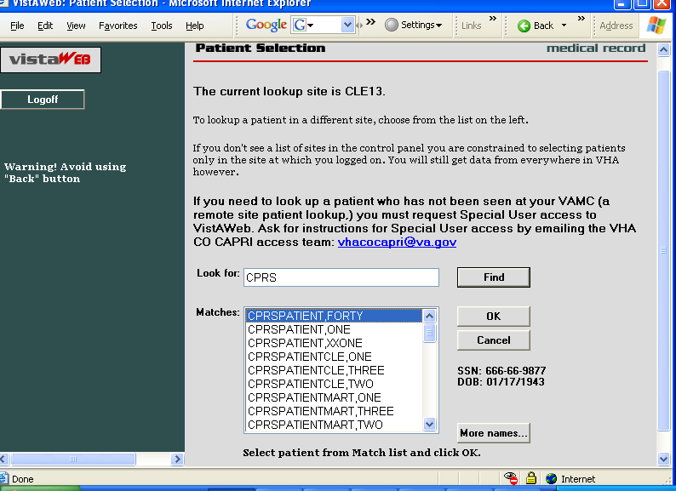
In the example above, the user does not have Special User access, so patient selection is limited to the local site where the user first logged in. There is no list of alternate patient selection sites on the left side of the VistAWeb Patient Selection screen.

Special Users
By default, users of VistAWeb are permitted to select patients that are in the local VistA system where the user logs in. VistAWeb will retrieve data for these patients from all sites where the patients have records. Some users (researchers or referral coordinators, for example) may need to select patients that are not in the local VistA. These users will require Special User access, which can be granted for one site in addition to the login site, several sites, an entire VISN, or all sites nationally.
After logging in to VistAWeb, Special Users will see the Patient Selection screen, with a list of sites accessible for patient selection (Figure 20).

Figure 20: Special User Multiple Site and Patient Selection
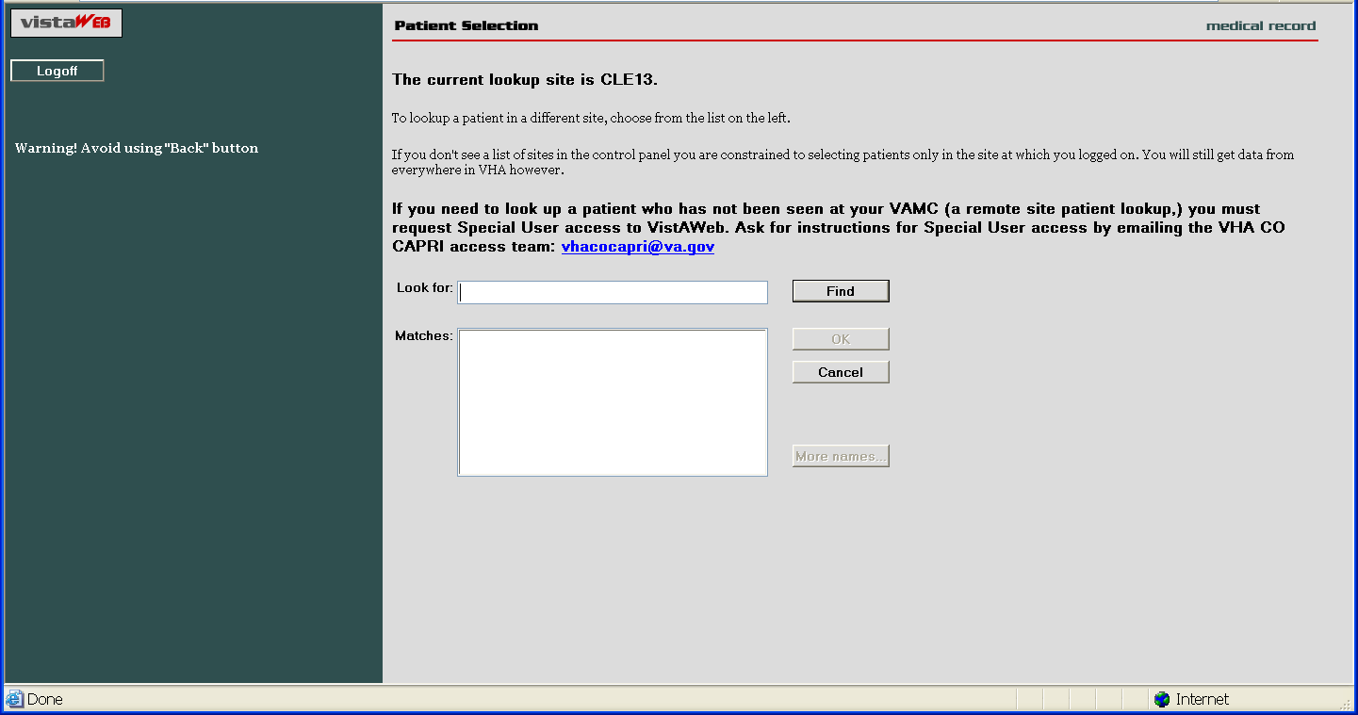
In the example above, the user is a Special User who has access to perform patient selection at all VISN 11 sites, which are listed on the left side of the screen. To select a patient from a site other than the login site, you must first click on the desired site on the left side of the screen and then perform patient selection.

Requesting Special User Access
Requests for Special User access fall into one of three categories:
- National Programs requiring “Special User” access, such as Blind Rehab, Transplant, War Related Illnesses, and so forth
- VA Researchers requiring “Special User” access for the purpose of approved research projects
- All Others, for example, local users, requiring “Special User” access to multiple VA sites for the purpose of clinical opinions, referral coordination, and so forth
All users requesting “Special User” access will be required to verify completion of the annual VHA Privacy Policy Training and VA Information Security Awareness Course and to sign the Rules of Behavior prior to approval of the request.
Individuals requesting Special User access to VistAWeb should contact vhacocapri@va.gov.

Sensitive Patient Warning
Similar to CPRS, standalone VistAWeb displays a warning to you if you select a patient who has been flagged or designated as a Sensitive Patient (Figure 21). VistAWeb differs from CPRS in that it will display the warning message to you if the patient is sensitive in ANY of the sites from where the sensitive data will be retrieved. If you elect to proceed, notification will be sent to the Information Security Officer (ISO) at any and all sites where the patient data is marked sensitive. Both standalone and CPRS-spawned versions of VistAWeb also display the sensitivity status on the Sites & Notices screen.

Figure 21: Restricted Record Warning
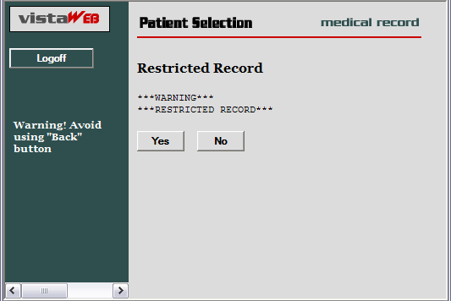

Refresh Patient Data
A Refresh Patient Data button has been added to VistAWeb that allows you to update reports without having to log off and back into a VistAWeb session (Figure 22) when new data is added to the patient’s record in CPRS. Clicking on the Refresh Patient Data button returns you to the Sites & Notices screen from which you can navigate back to the appropriate report to see the new data.

Figure 22: Refresh Patient Data Button
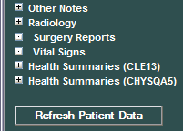
Category 1 Patient Record Flags
Category I Patient Record Flags are now displayed in standalone sessions of VistAWeb before the user is permitted to “Continue to Patient Record” (Figure 23). The Category I flags are also displayed in both standalone and spawned versions of VistAWeb on the Sites & Notices screen (Figure 24).

Figure 23: Example Category I Patient Record Flag in Standalone VistAWeb
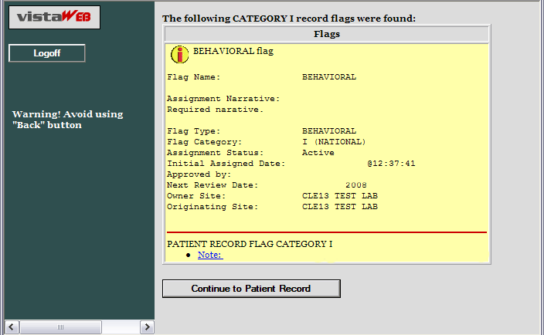

Figure 24: Example Category I Patient Record Flag on the Sites & Notices Screen
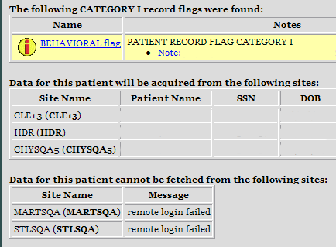

Using VistAWeb
After the Patient Selection page, all VistAWeb functionality for a Special User is the same as for other users, except that there is no clinical context management as described earlier in Patient Context in CPRS-Spawned VistAWeb.

Automatic Retrieval of Data from Multiple Sites
When the patient is first selected, VistAWeb determines how many sites the patient has visited and displays a message similar to the following to let you know that VistAWeb is establishing connections to those systems (Figure 25).

Figure 25: Please Wait…Message
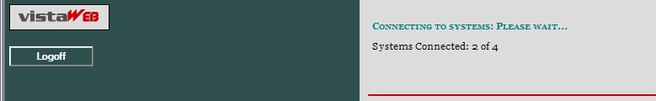
The Sites and Notices page is then displayed, which includes a list of sites where data for that patient will be retrieved. In the following example (Figure 26), data will be retrieved from CLE13, HDR, and CHYSQA5. If VistAWeb cannot connect to some of the systems (sites) where the patient has been seen, that information is supplied in table format below the sites that are connected. The Last Seen field in the tables is only populated when the Master Patient Index (MPI) has that information to report.
On the left side of the screen, there is a list of reports for which VistAWeb is able to retrieve patient data. For more detail regarding the type of reports, refer to the Expanded List of All Reports section of this manual.

Figure 26: Patient Data Available at Multiple Sites
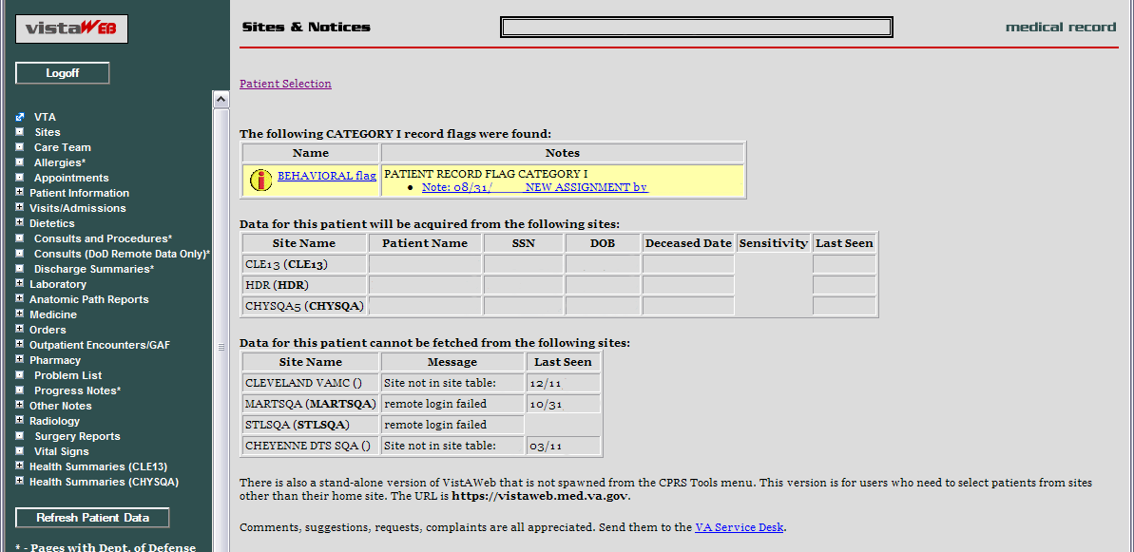

Expanded List of All Reports
Entries preceded by a plus sign (+) can be expanded to show sub-reports by clicking the mouse on the plus sign (+). Expanded lists can be collapsed by clicking the mouse on the minus sign (–).Example 1 is a fully expanded list of reports retrieved by VistAWeb, with the exception of the list of Health Summaries which has been truncated. In addition to National and local VistA health summaries, VISN level health summaries are available. Consequently, the list of available summaries can be quite long and will vary depending on the user’s login site. The list of health summaries is similar to the Health Summary list available from the Reports tab in CPRS.
Items on the menu that are followed by this symbol (†) will include DoD data, if available.
Example 1: Expanded List of VistAWeb Reports
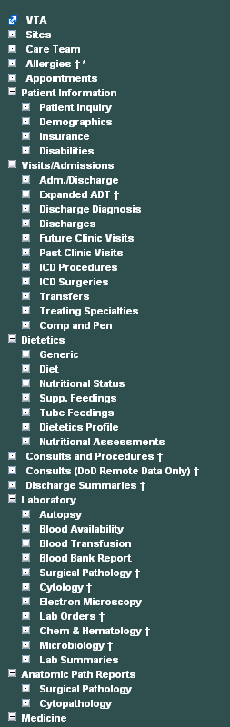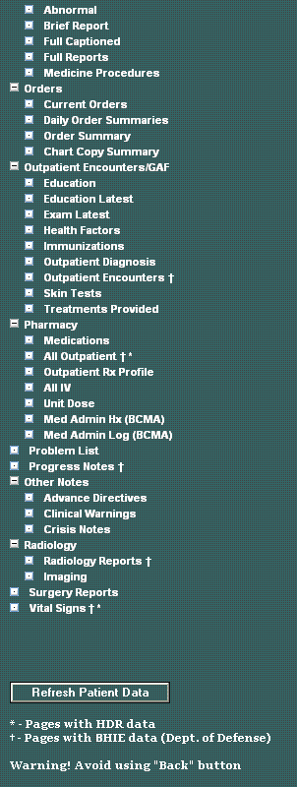

Report Examples
There are over 80 different reports available in VistAWeb. A representative sampling is presented here to demonstrate the different types of reports and formatting options.

Text Reports
Text reports are the most basic of all reports available to users. Text is displayed in a non-interactive mode and is very similar to the corresponding reports found in CPRS from the Reports tab. One example of a Text report is the Patient Inquiry report (Figure 27). All site data is retrieved for the selected report, and the patient’s data for the associated site is placed within the tab from where the data was retrieved. In the example below, there are four tabs: MARTSQA, CLE13, STLSQA, and CHYSQA5. To view data retrieved from MARTSQA for the selected patient, click the mouse on the MARTSQA tab. If any particular report is not available from a site where the patient has been seen, or if there is no data for a specified date range, then that site’s report tab will return the statement “No Data Found.” See Figure 32.

Figure 27: Patient Inquiry Text Report
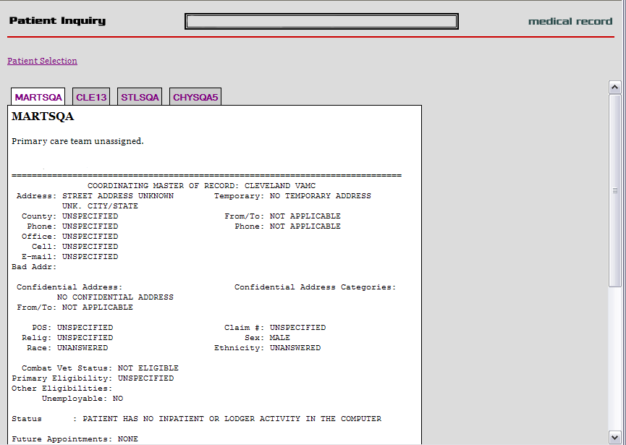

Text Report with Date Range Option
In report screens where date ranges can be typed, two digits can be entered for years, and dashes can be entered instead of slashes. VistAWeb will reformat to the dd/mm/yyyy format for the user, e.g., 12-11-05 will be reformatted to 12/11/2005 automatically. Typing in a date range clears any set radio button. Likewise, setting a radio button for one of the available time periods will clear dates previously typed into the From/To fields. The following composed sequence demonstrates that VistAWeb corrects the date format and then shows that clicking the All Results button clears the To/From date fields (Figure 28).
Figure 28: Date Range Entry and Radio Button Selection
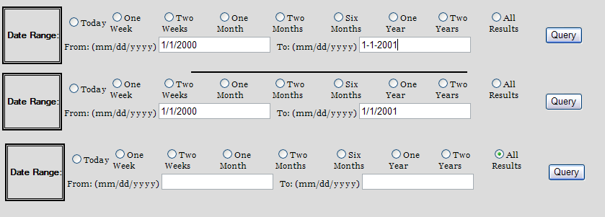
When these reports are generated they are presented in table format, which typically can be sorted and can contain data from multiple sites, as with Allergies, Outpatient Pharmacy, and Vital Signs reports. In the following example report of Progress Notes (Figure 29) or Chem & Hematology (Figure 29b), the initial default query is performed automatically for a one-year time period, and the maximum number of items per site to return is defaulted to 50. You can type in a different number or click in the All Data box to retrieve all the items for the specified period. You can select a different time period or enter a From/To date range, and you can specify a different maximum number of items to return. Click the mouse on the Query button to run the report for the new time period or date range and number of items. Note that, if the default number is deleted, either a minimum of 1 item must be requested or All Data must be checked for the specified time period. Otherwise, an error message is displayed.

Figure 29: Progress Notes Report with Date Range, Number, and Query
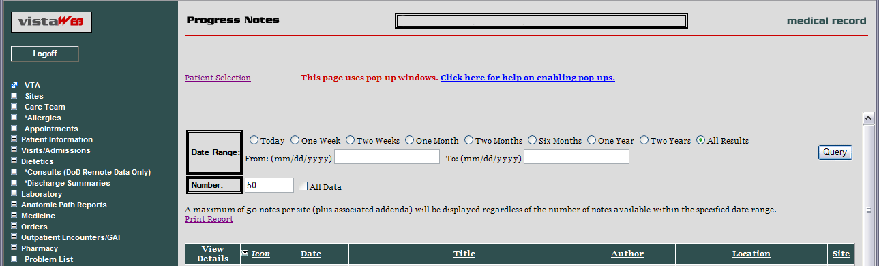
Figure 30b: Progress Notes Report with Chem & Hematology
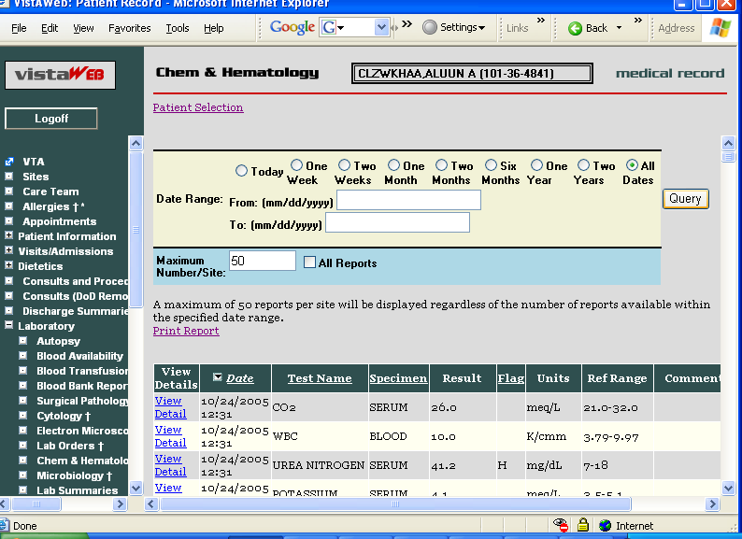

Predefined Filtering and Date Range
The Pharmacy – All Outpatient report often contains a large number of entries, depending on the patient’s history of outpatient prescriptions. Providing shorter date ranges allows for the quicker retrieval of data. For this report, the Date Range selection criteria defaults to 15 Months. You can select 2 Years or All Results by clicking on their radio buttons and then clicking the Query button (Figure 31). Note that the expired dates for the two medications shown are 1995 and 1996, and these would not have been retrieved by selecting 15 Months or Two Years.
Figure 31: Date Range Selection Criteria for All Outpatient Pharmacy Report
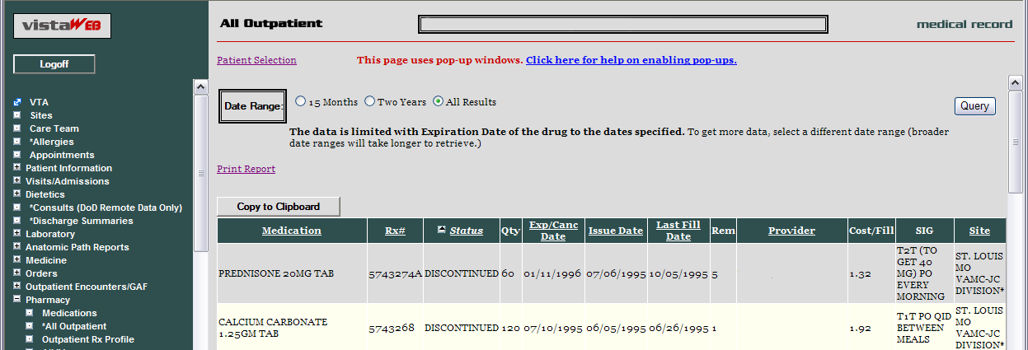
Some reports require you to enter the date range before the report will appear (Figure 32). This is the case for queries that have the potential to return very large amounts of data or where filtering the data lends usability to the report. Summaries, such as Discharge, Lab, some Order summaries, and both of the Med Admin Hx and Med Admin Log reports, tend to generate large volumes of data. Narrowing the date range for a report for a patient’s summary data may improve the speed of the data retrieval.
Some reports that do not require a date range include the following: Sites, Care Team, Allergies, Appointments, Patient Inquiry, Patient Demographics, Patient Insurance, Dietetics Profile, Blood Bank, Daily Order Summary, Medications, Outpatient Rx Profile, All IV, and Imaging.

Figure 32: Date Range for Lab and Other Large Volume Reports
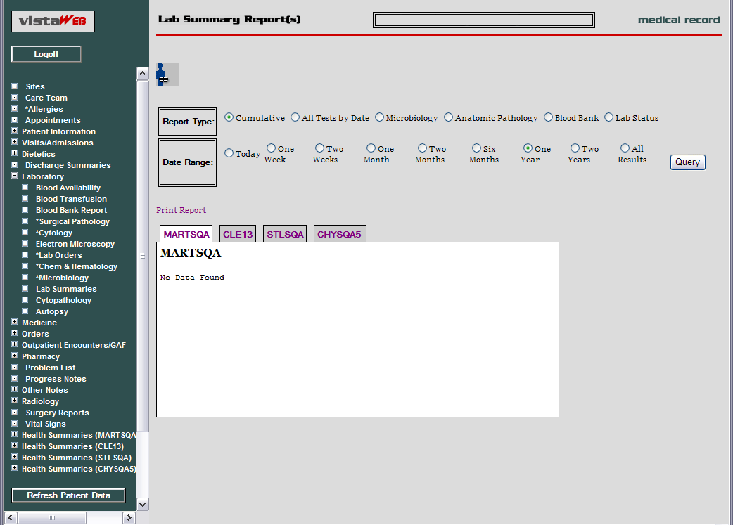

Data Grid Style of Report
The data grid style of report presents data in the form of a grid or table, with the data being retrieved and displayed according to a specified date range. The data for most of the tables can then be sorted in multiple ways. The underlined column headers indicate which columns may be used for sorting. Report data is generally retrieved and presented with the most recent date at the top, descending to the earliest date at the bottom. For some reports, Vitals for example, data from multiple sites is presented strictly by date, without consideration for the site. For some other reports, Problem List for example, the problems from multiple sites are displayed by status (active first) and then in descending date order for one site and then descending order for the next site, and so on. Then inactive problems are listed if there are any. In most of the reports that have a date column, clicking the date won’t change the sorting of that column unless some other sort, alphabetical, for example, had been done which upset the descending date order.

Data Grid with View Detail
The data grid that contains a View Detail column permits you to view additional detail about a selected item in a row. In this example, Progress Notes titles are listed in VistAWeb (Figure 33). To view the actual text of the note, click on the View Detail link for the note of interest.

Figure 33: Progress Notes

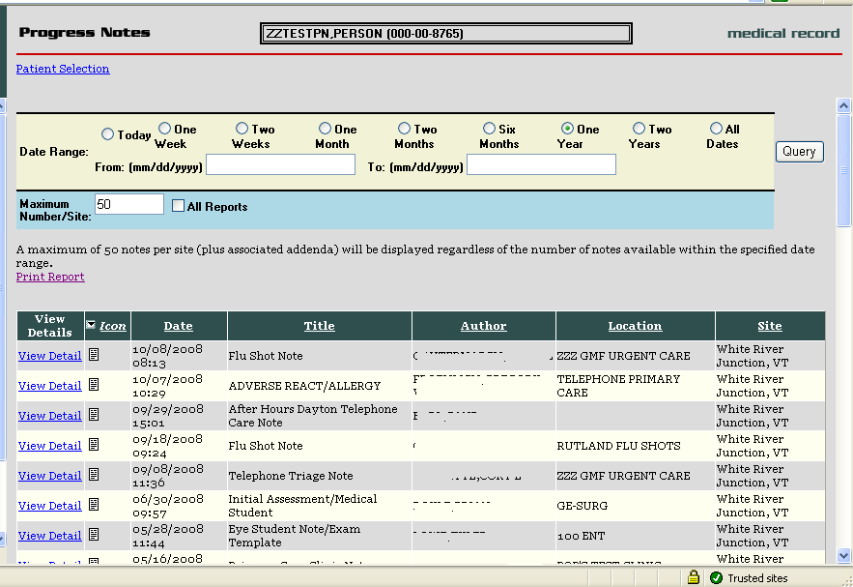

When you click on the View Detail link, the detail of the selected note appears in a pop-up box, represented in the example below (Figure 34). Click on the Print or Close buttons to effect the desired action.

Figure 34: View Details of Progress Note
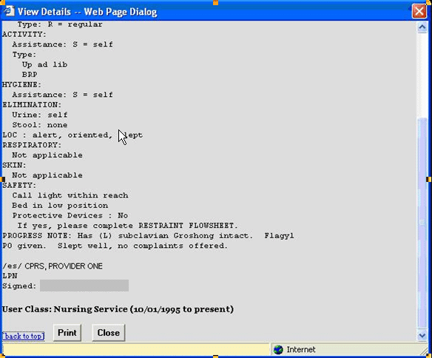
In the following Vital Signs example report, note that three of the Site column listings display HT as the site where the vitals were taken. The HT indicates the data was supplied through the Home Telehealth (HT) interface (Figure 35).

Figure 35: Vital Sign Report Presented as Table
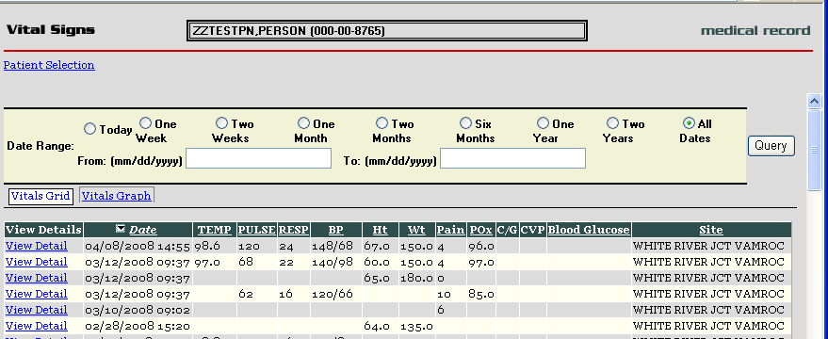

When you select View Details of an HT site from the Vital Signs screen, additional information is provided about the method of data entry, qualifiers, vitals measuring devices, and that data standardization has been accomplished for this vital sign record (Figure 36).

Figure 36: View Details of HT Standardized Vitals
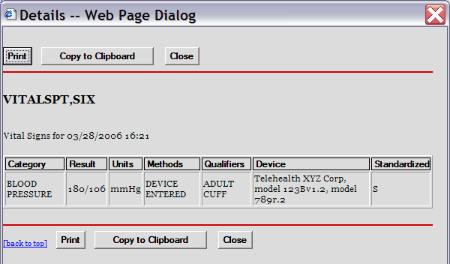
If the vitals data is coming from the HDR-IMS repository, but was not entered through the HT interface, the Details – Web Page Dialog will show the letter S in the Standardized column and any other data that was entered through the Vitals package that maps to other column headings. In the following example, the Methods and Qualifiers for supplemental oxygen that was delivered to the patient are shown (Figure 37).

Figure 37: View Details of Non-HT Standardized Vitals
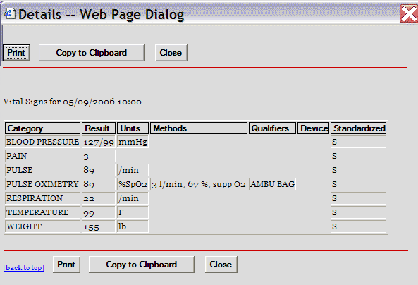
If the vitals data is coming from the HDR-Historical database or a VistA site, the Standardized column does not display the letter S and no data is supplied for Units, Methods, Qualifiers, or Device (Figure 38). If for some reason the HDR databases are inaccessible, VistAWeb still polls the VistA sites where the patient has been seen and will return any available requested data for display.

Figure 38: View Details of Non-Standardized Vitals
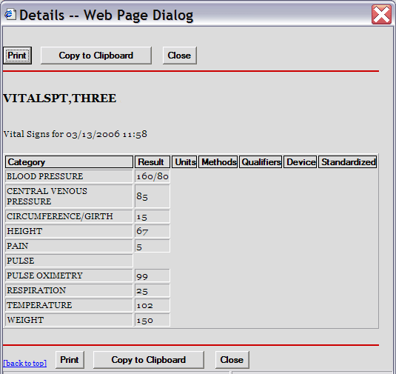

Data Grid with Copy to Clipboard Option
The following example of a Medications report lists a variety of medications and their statuses, along with Copy to Clipboard button (Figure 39). Providers often find it useful to copy lists of active and suspended medications to a patient note. When you click the mouse on the Copy to Clipboard button, the list of Active and Suspended medications is automatically copied to the clipboard and grouped by Status. Discontinued and expired medications are not copied.
NOTE: When you do a copy to clipboard, this data is available to other web pages, which poses a patient safety issue, since patient information can be seen by other web pages
In V8, users can set up an option that doesn’t allow the clipboard data to be available to other web pages.

Figure 39: Copy to Clipboard
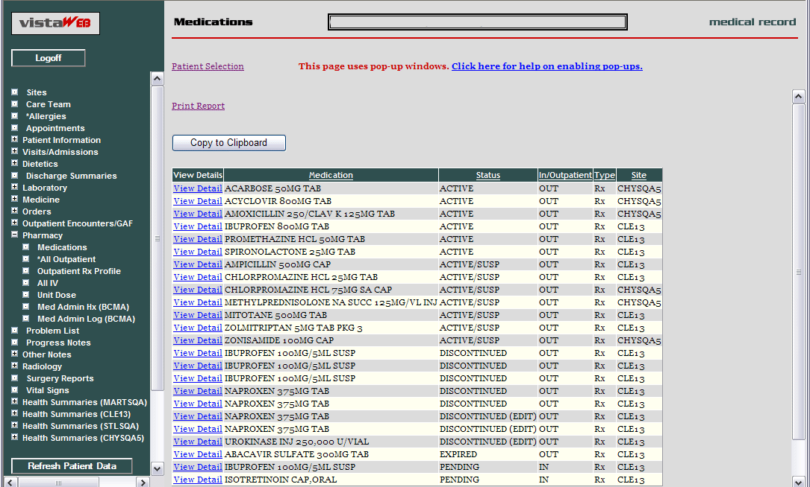
The list can be pasted into another document or a Progress Note within CPRS. The following screen capture shows active and suspended medications from a Medications report grouped by Status and pasted into a CPRS note (Figure 40).

Figure 40: Medications from VistAWeb Pasted into CPRS Progress Note
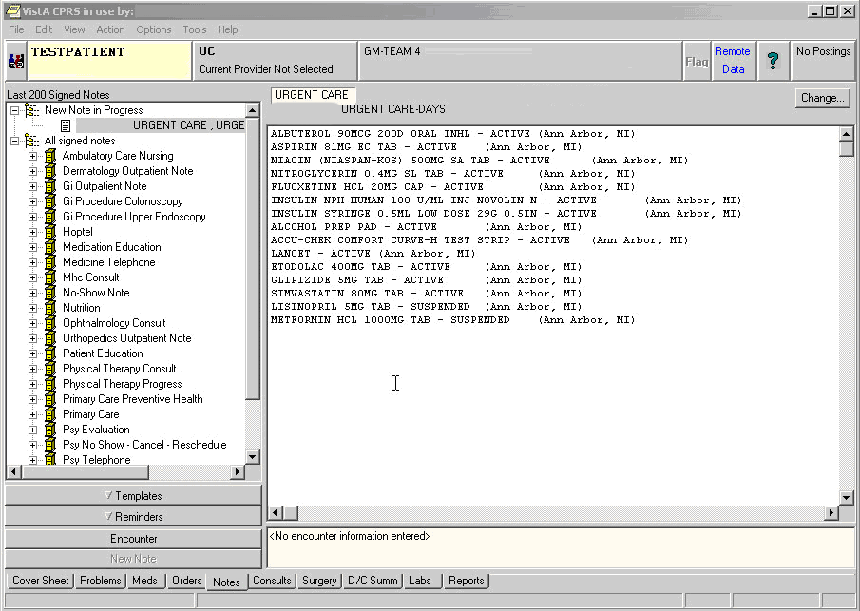
Note: VistAWeb displays Non-VA and Herbal/OTC medications if applicable. In the following screen capture of a Medication report (Figure 41), the Type field has one medication listed as Non-VA. The View Detail for this medication provides details and states “Patient wants to buy from Non-VA pharmacy.”
Figure 41: Non-VA Medications
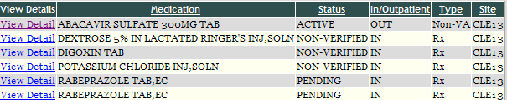

VistAWeb Timeout
VistAWeb has a 15-minute inactivity timeout, which disconnects you from the current session if you don’t respond to the 2-minute Web Page Dialog Countdown. Click the Don’t close VistAWeb button to reset the timer to 15 minutes. Click the Close VistAWeb button to exit VistAWeb immediately (Figure 42).

Figure 42: VistAWeb Timeout Dialog Box
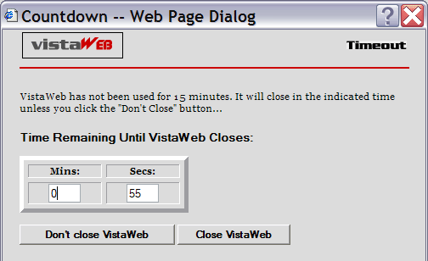
If you allow VistAWeb to timeout, the following Microsoft Internet Explorer dialog box is displayed telling you that VistAWeb is trying to close the window. If you click the No button, an empty Internet Explorer window will remain. If you want to continue to use VistAWeb, you will have to reestablish your connection, and since VistAWeb will bring up the new session in a new window anyway, you should click the Yes button to eliminate this empty window (Figure 43).

Figure 43: Internet Explorer Close Dialog
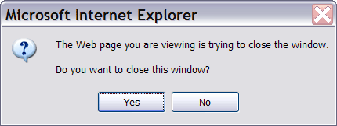
Under some circumstances, VistAWeb will cease operations. This is usually related to running a standalone session and a spawned session of VistAWeb at the same time. When this occurs, you will be presented one of the following messages indicating an appropriate course of action for you to pursue (Figure 44 and Figure 45).

Figure 44: Empty Session Message – Rerun VistAWeb
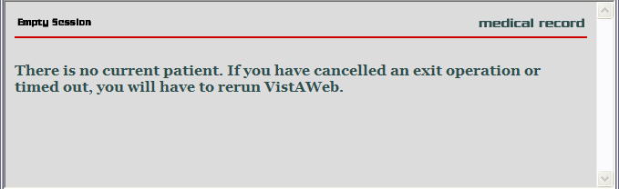

Figure 45: Empty Session Message – Use a Different Browser Window
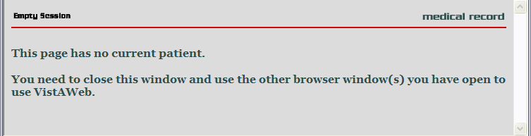

Acronyms and Abbreviations
Term | Definition
2D | 2 Dimensional
3D | 3 Dimensional
BHIE | Bidirectional Health Information Exchange
CCOW | Clinical Context Object Workgroup
CDS | Clinical Data Service
CHDR | Clinical Data Repository (DoD) – Health Data Repository (VHA)
CPRS | Computerized Patient Record System
DoD | Department of Defense
FHIE | Federal Health Information Exchange
GUI | Graphical User Interface
HDR | Health Data Repository
HDR II | Health Data Repository II – final stage of project to develop and deploy an HDR
HDR-Hx | Health Data Repository-Historical
HDR-IMS | Health Data Repository-Interim Messaging Solution
HL7 | Health Level 7
HT | Home Telehealth
IE | Internet Explorer (Microsoft)
IHS | Indian Health Service
IRM | Information Resource Management
ISO | Information Security Officer
JPTA | Joint Patient Tracking Application
LHR | Legal Health Record
MPI | Master Patient Index
RDV | Remote Data View
RPC | Remote Procedure Call
URL | Uniform Resource Locator (internet address)
VA | Department of Veterans Affairs
VAMC | Department of Veterans Affairs Medical Center
VHA | Veterans Health Administration
VISN | Veterans Integrated Service Network
VistA | Veterans (Health) Information Systems and Technology Architecture
VTA | Veteran Tracking Application

